
Web development (WEDE5020)
Onele Qose

ST10533409

Table of Contents Proposal 1
1. Organisation Overview: 2
2. Website Goals and Objectives: 2
3. Current Website Analysis: 3
4. Proposed Website Features and Functionality: 3
5. Design and User Experience: 4
6. Technical Requirements: 6
7. Timeline and Milestones: 7
8. Budget: 7
9. Reference: 8

Organisation Overview:
- Name: Dr Dana’s Practice
- Brief History: This practice was founded and established in 2022 after the tragic state of disaster in South Africa. A young woman leveraged her qualification- a Bachelor of Dental Surgery- and formed employment for herself. The practice is known as Dr Dana’s Practice. The mission was to provide contemporary, patient-focused dental care in one location. Over time, the practice has grown and expanded to become something big, to a point where Dr Dana has two dental practices.
- Mission Statement: To provide patients of all ages with thorough, excellent, painless dental care so they can retain their oral health and smile confidence for the rest of their lives.
- Vision Statement: The vision is to become the most innovative and recognised dental office in East London, known for flawless modern care, professional quality, and patient care.
- Target Audience: This organisation targets families of all ages and working professionals seeking to be more confident and to get reliable and cosmetic dental care.

Website Goals and Objectives:
- Specific goals for the website:
- Brand recognition and boost digital exposure: Creating a dedicated website will enable the practice to engage potential clients seeking dental care in East London. As a result, this website will boost accessibility for out-of-town clients or new residents, allowing them to quickly find the practice using standard search engines like Google.
- Keeping patients and expanding the business: Draw in new long-term patients at both clinic sites by highlighting specialized dental care and patient reviews. Also set up automated notifications or straightforward access to routine examination information to enhance retention of current patients.
- Becoming different from local competitors: Through the website, it will show individuals modern facilities, a pain-free care approach, and convenient dual locations to differentiate itself in the East London region.
- Key Performance Indicators (KPIs)
- Increase traffic: Monthly unique visitors and search engines like Google
- Lead generation: Direct phone inquiries and online booking form conversions
- Patient engagement: Bounce rate and user engagement duration
- User experience: Page rendering time and mobile responsiveness

Current Website Analysis:
- Strengths
- Showcasing services: The website showcases the practice's dental services, such as teeth whitening, braces, dentures, and routine check-ups, making it easy for patients to see which treatments are available.
- Able to book at any time: The website allows patients to access information and book appointments online at any convenient time, providing greater accessibility.
- Weaknesses
- Cybersecurity risks: Hackers could breach patients’ confidential and personal information.
- Innovation within the website: Some users may find it difficult to navigate through the website, as a result making the website less user-friendly (GeeksforGeeks, 2025; Frontier Business, 2023).
- How to improve weaknesses
- Cybersecurity risks can be improved by having strong security measures like frequent program updates, strong passwords, and SSL encryption.
- To enable the website innovation to be user-friendly, the design should be simple and have clear options (Krug, 2014; Nielsen Norman Group, n.d.)

Proposed Website Features and Functionality:
- Navigation and Header:
- Click-to-call button for patient enquiries
- Navigation menu: Home, Services, Gallery, Location, and Contact
- Homepage
- The practice slogan: “Your Smile, Our Passion,” and location.
- Includes Book an appointment and WhatsApp Us buttons.
- Highlights key information: 2 locations and Medical Aid Approved.
- Introduces Dr Dana to build patient trust.
- Services
- Displays treatments including:
- Tooth extractions
- Braces 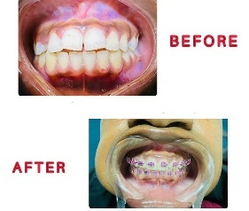
- Oral hygiene 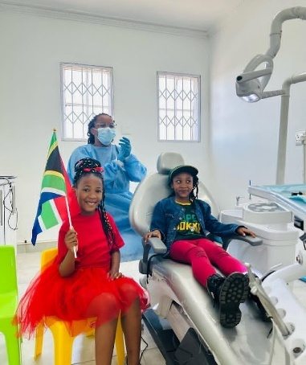
- Dentures 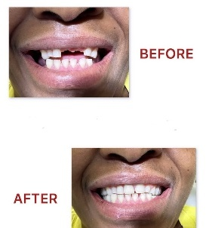
- Supporting pages
- WhatsApp interaction: Enables quick appointment booking and communication
- Gallery: Photos of the practice and treatment results
- Locations: Addresses and maps for both branches

Design and User Experience:
- Overall aesthetic and branding
In order to develop patient trust and showcase Dr. Dana’s modern, pain-free procedures, a contemporary, clean, and clinical design was developed. Patients will feel more at ease thanks to the clear card layouts.
- Design specifications
Colour scheme:
- Teal: Primary buttons and highlights
- Emerald green: WhatsApp button
- Off-white: Backgrounds
- Dark slate: Text and headings
Typography:
- Headings: Playfair Display
- Body text: Inter
Layout and design:
- Sticky navigation bar
- Hero section with Dr Dana’s image and call-to-action buttons
- Responsive design for desktop and mobile devices
- Card-based layout for services
User experience:
- Clear contact information
- Online appointment booking
- Simple navigation
Wireframe:
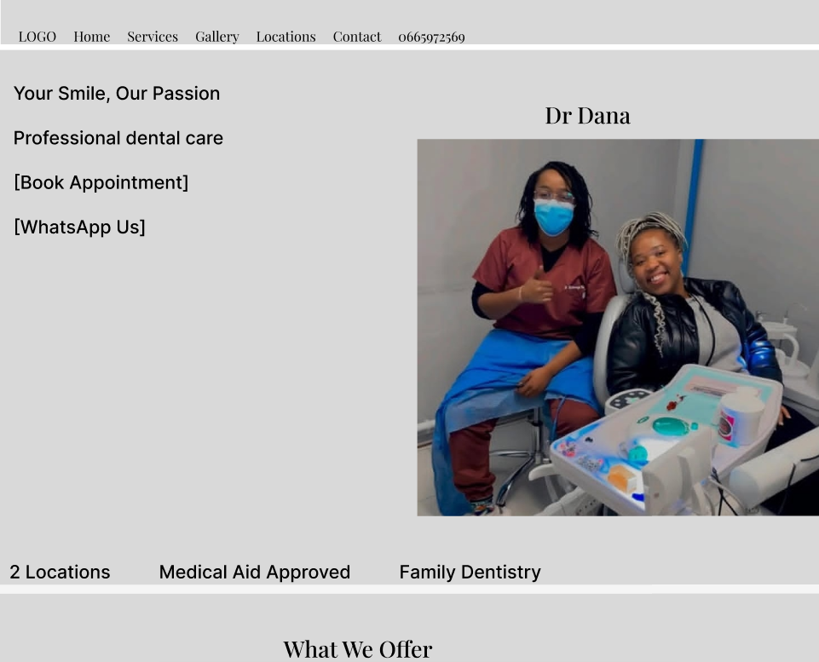
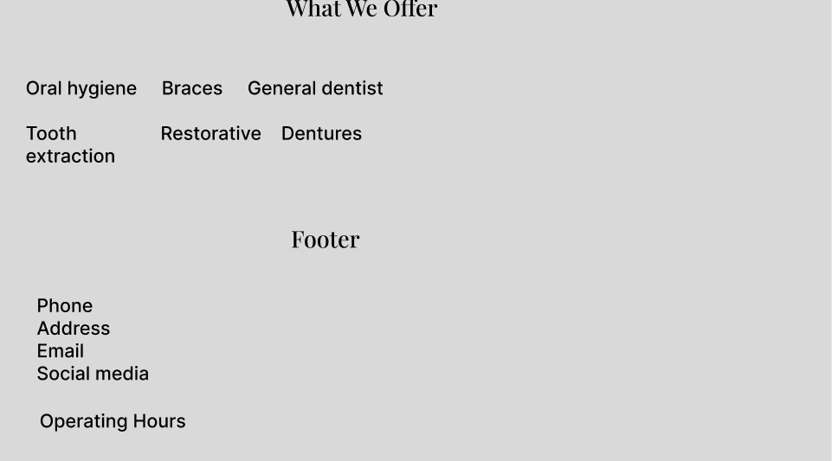

Technical Requirements:
Domain Name and Hosting
Domain Name: Secure a local.co.za domain, for example drdanaspractice.co.za, to establish local search authority and credibility in South Africa.
Hosting Provider: Managed, high-speed web hosting with guaranteed SSL encryption (HTTPS), daily automated backups, and 99.9% uptime.
Programming Languages and Frameworks
Frontend: HTML5 (semantic structure), CSS3 / Tailwind CSS (responsive styling), and JavaScript (interactive elements like sticky headers and service grids).
Backend Framework: WordPress / PHP or React / Node.js to handle dynamic content updates, booking form submissions, and secure API integrations.
Integrations and safety
WhatsApp API: Direct integration allowing patients to launch WhatsApp chats instantly from desktop or mobile devices.
Security Standards: SSL Certificate installation, DDoS protection, and compliance with local data protection regulations (POPIA) for handling patient inquiry information.

Timeline and Milestones:
Days | Activity | Milestone
Day 1 | Did research about the practice by contacting the admin and asking for permission to use their pictures. | Did planning and made sure I had all the required information.
Day 2 | Started with the proposal | I started from the organisation overview and stopped at Design and user experience.
Day 3 | Day 3, I picked up where I left off | Completed the technical requirements and ended with a reference.

Budget:
Items | Estimated cost (ZAR)
Website design and development | R9000
Domain Name (.co.za) | R250 per year
Web Hosting | R1500 per year
Website Maintenance | R400 per month
Content creation and images | R1000
Total initial cost | R12150

Reference:
dana_dentistry02; 2024; I’m done trying; June; https://www.iinstagram.com/p/c73jB7kITSX/?igsh=MTBpcnA4a3hqNmtiYw==; [29 July 2026].
dana_dentistry02; 2024; Wire not smile; June; https://www.instagram.com/p/C6Dpgt6owIA/?igsh=YmFuNmJjbDdyb2o4; [29 July 2026].
dana_dentistry02; 2023, We backing the Bokke!!!; October; https://www.instagram.com/p/Cy8PadhIPDh/?igsh=MTIsazhyMHU2anpkaw==; [30 July 2026].
GeeksforGeeks. 2025. Types of cyber-attacks. [Online] Available at: <https://www.geeksforgeeks.org/cybersecurity/types-of-cyber-attacks/ > [Accessed 30 July 2026].
Frontier Business. 2023. Pros and cons of having a website. [Online] Available at:<https://business.frontier.com/blog/pros-and-cons-of-having-a-website > [Accessed 30 July 2026]
Nielsen Norman Group. n.d. Usability 101: Introduction to usability. [Online] Available at:< https://www.nngroup.com/articles/usability-101-introduction-to-usability/ > [Accessed 30 July 2026].
Krug, S. 2014. Don't Make Me Think, Revisited: A Common Sense Approach to Web Usability. 3rd ed. Berkeley, CA: New Riders.

Proposal 2

Organisation overview
- Name: Hair Palace Salon
- Brief History: In order to offer expert hair and beauty treatments in a friendly setting, Hair Palace Salon was founded in 2024. The salon provides manicure care, hair treatments, weave installations, braiding, and hair cleaning. Its goal is to provide clients with the greatest possible service and customer care so they may feel and look their best.
- Mission statement: To offer expert, reasonably priced, and superior hair and beauty services that enable each client to feel and look their best via outstanding customer service, knowledgeable staff, and a friendly salon setting.
- Vision statement: To establish ourselves as a reputable, top-tier hair and beauty salon with a stellar reputation for client satisfaction and high-quality services.
- Target Audience: Women, men, students, and working professionals who are looking for affordable, high-quality hair and beauty services, as well as clients preparing for special occasions.

Website Goals and Objectives
Creating a professional online presence and drawing in new customers are the main objectives of the Hair Palace Salon website. The salon's services, such as hair washing, braiding, hair treatments, weave installations, nail services, and other beauty treatments, will be highlighted on the website. Additionally, it will offer pricing, company hours, contact details, and a way to schedule an appointment online.
Key Performance Indicators (KPIs):
- Boost traffic to your website.
- Boost the number of online appointments.
- Enhance consumer inquiries via the contact site.
- Boost interaction on the services and galleries pages.

Current Website Analysis
- Strengths
- The location and hours of operation of the salon are readily visible to clients.
- The website offers contact information and data about the salon's offerings (Krug, 2014)
- Weaknesses
- The website is not entirely mobile-friendly and loads slowly.
- Users find it challenging to locate information quickly due to the complicated navigation (Krug, 2014; Nielsen Norman Group, n.d.)
- Improvements
- Use user-friendly page layouts and distinct categories to enhance the navigation menu.
- The salon may lose potential clients to rivals with websites due to its low online visibility.

Proposed Website Features and Functionality
The proposed website will include:
- Home page
- About Us page
- Services page
- Gallery page
- Appointment Booking page
- Contact Us page with Google Maps integration
- Social media links
- Mobile-responsive design
- Secure contact form

Design and User Experience
The website will have a modern and elegant appearance that reflects the salon's brand.
- Colour Scheme: Black, gold, and white to create a luxurious and professional image.
- Typography: Poppins for headings and Open Sans for body text to improve readability.
- Layout: A clean, responsive layout with simple navigation and clear call-to-action buttons.
- User Experience: Easy navigation, fast loading speed, mobile compatibility, and accessible menus will ensure visitors can quickly find information.
- Wireframe: The homepage will display the salon logo, navigation menu, hero banner, featured services, and contact details.
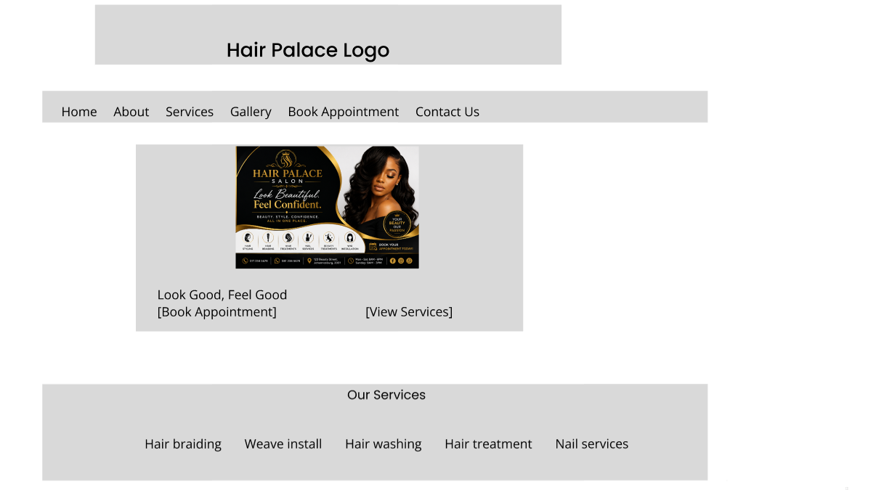

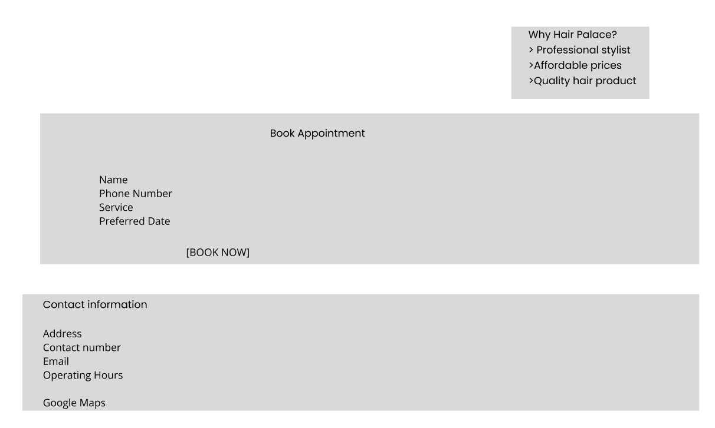

Technical Requirements
For responsive design, the website will make use of HTML5, CSS3, JavaScript, and Bootstrap. A reputable web hosting company will handle hosting, and Hair Palace Salon will have a.co.za domain name registered. SSL encryption will be used to enhance website security and protect client data.

Timeline and Milestones
Days | Activity | Milestone
Day 1 | Did research about the practice by contacting the admin and asking for permission to use their pictures. | Did planning and made sure I had all the required information.
Day 2 | Started with the proposal | I started from the organisation overview and stopped at Design and user experience.
Day 3 | Day 3, I picked up where I left off | Completed the technical requirements and ended with a reference.

Budget
Items | Estimated cost (ZAR)
Website design and development | R9000
Domain Name (.co.za) | R250 per year
Web Hosting | R1500 per year
Website Maintenance | R400 per month
Content creation and images | R1000
Total initial cost | R12150

Reference
Nielsen Norman Group. n.d. Usability 101: Introduction to usability. [Online]. Available at: https://www.nngroup.com/articles/usability-101-introduction-to-usability/ [Accessed 31 July 2026].
Krug, S. 2014. Don't Make Me Think, Revisited: A Common Sense Approach to Web Usability. 3rd ed. Berkeley, CA: New Riders.

